**1. Write a program in C to store elements in an array and print them.**

#include <stdio.h>

int main() {

int arr[10];

int i;

printf("Input 10 elements in the array :\n");

for(i=0; i<10; i++) {

printf("element - %d : ",i);

scanf("%d", &arr[i]);

}

printf("\nElements in array are: ");

for(i=0; i<10; i++) {

printf("%d ", arr[i]);

}

printf("\n");

return 0;

}

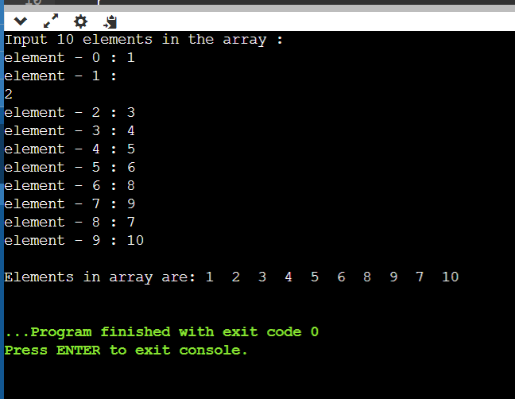

**2. Write a program in C to read n number of values in an array and display**

**them in reverse order.**

#include <stdio.h>

int main() {

int i, n, a[100];

printf("\n\nRead n number of values in an array and display it in reverse order:\n");

printf("Input the number of elements to store in the array :");

scanf("%d", &n);

printf("Input %d number of elements in the array :\n", n);

for (i = 0; i < n; i++) {

printf("element - %d : ", i);

scanf("%d", &a[i]);

}

printf("\nThe values stored in the array are : \n");

for (i = 0; i < n; i++) {

printf("% 5d", a[i]);

}

printf("\n\nThe values stored in the array in reverse are :\n");

for (i = n - 1; i >= 0; i--) {

printf("% 5d", a[i]);

}

printf("\n\n");

return 0;

}

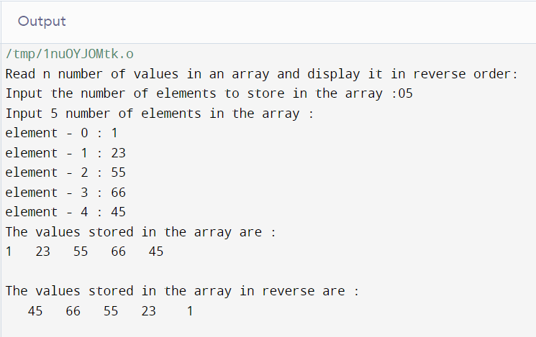

**3. Write a program in C to find the sum of all elements of the array**

#include <stdio.h>

int main() {

int i, n, arr[100], sum = 0;

printf("Enter the number of elements in the array: ");

scanf("%d", &n);

printf("Enter the elements of the array:\n");

for (i = 0; i < n; i++) {

scanf("%d", &arr[i]);

sum += arr[i];

}

printf("The sum of all elements in the array is: %d\n", sum);

return 0;

}

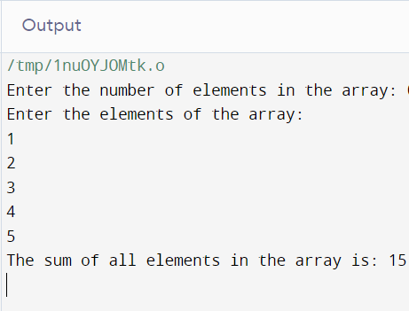

**4. Write a program in C to count the total number of duplicate elements in**

**an array.**

#include <stdio.h>

int main() {

int i, j, n, count = 0;

int arr[100];

printf("Enter the number of elements in the array: ");

scanf("%d", &n);

printf("Enter the elements of the array:\n");

for (i = 0; i < n; i++) {

scanf("%d", &arr[i]);

}

for (i = 0; i < n; i++) {

for (j = i + 1; j < n; j++) {

if (arr[i] == arr[j]) {

count++;

break;

}

}

}

printf("The total number of duplicate elements in the array is: %d\n", count);

return 0;

}

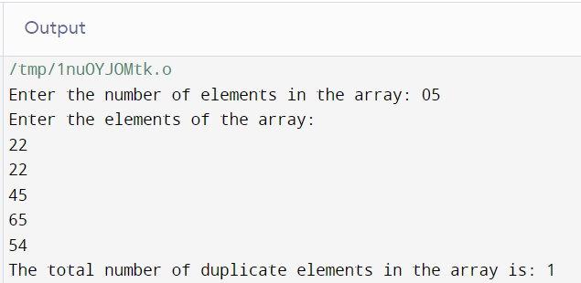

**5. Write a program in C to print all unique elements in an array.**

#include <stdio.h>

int main() {

int i, j, n, arr[100], unique[100], unique_count = 0;

printf("Enter the number of elements in the array: ");

scanf("%d", &n);

printf("Enter the elements of the array:\n");

for (i = 0; i < n; i++) {

scanf("%d", &arr[i]);

}

for (i = 0; i < n; i++) {

int is_unique = 1;

for (j = 0; j < unique_count; j++) {

if (arr[i] == unique[j]) {

is_unique = 0;

break;

}

}

if (is_unique) {

unique[unique_count++] = arr[i];

}

}

printf("The unique elements in the array are:\n");

for (i = 0; i < unique_count; i++) {

printf("% 5d", unique[i]);

}

printf("\n\n");

return 0;

}

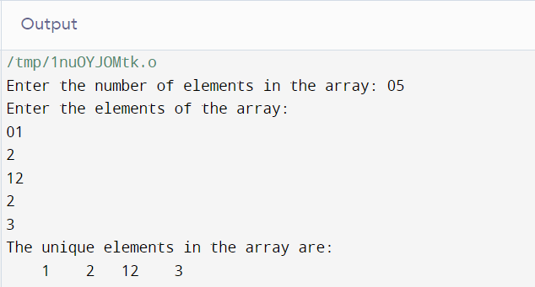

**6. Write a program in C to insert an element into an array at a specified**

**position.**

#include <stdio.h>

int main() {

int i, n, pos, value, arr[100];

printf("Enter the number of elements in the array: ");

scanf("%d", &n);

printf("Enter the elements of the array:\n");

for (i = 0; i < n; i++) {

scanf("%d", &arr[i]);

}

printf("Enter the position at which the element is to be inserted: ");

scanf("%d", &pos);

printf("Enter the value of the element to be inserted: ");

scanf("%d", &value);

for (i = n; i >= pos; i--) {

arr[i] = arr[i - 1];

}

arr[pos - 1] = value;

n++;

printf("The updated array is:\n");

for (i = 0; i < n; i++) {

printf("% 5d", arr[i]);

}

printf("\n\n");

return 0;

}

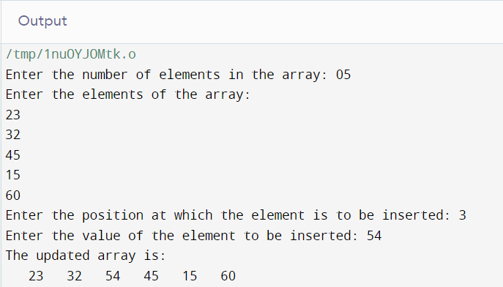

**7. Write a program in C to delete the element at the given index.**

#include <stdio.h>

int main() {

int i, n, pos, arr[100];

printf("Enter the number of elements in the array: ");

scanf("%d", &n);

printf("Enter the elements of the array:\n");

for (i = 0; i < n; i++) {

scanf("%d", &arr[i]);

}

printf("Enter the position of the element to be deleted: ");

scanf("%d", &pos);

for (i = pos - 1; i < n - 1; i++) {

arr[i] = arr[i + 1];

}

n--;

printf("The updated array is:\n");

for (i = 0; i < n; i++) {

printf("% 5d", arr[i]);

}

printf("\n\n");

return 0;

}

